Tugas Week 1 IS 429 Big data **Christopher Darren - 00000054804**

* 1. **1. Create GBQ Project using Public Data-sets**
  2. a. Create a New Project “bigquery-NIM-BDA1**”**
  3. 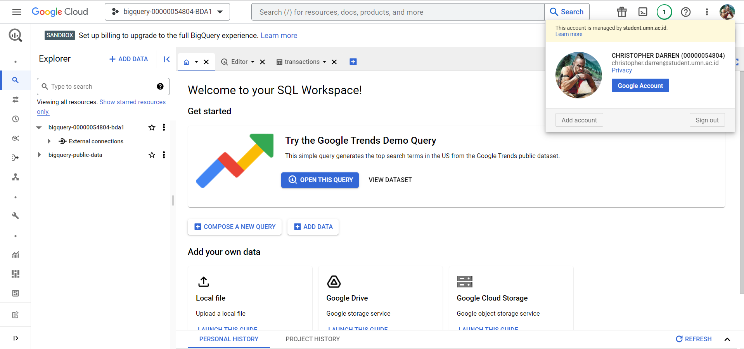
  4. b. Use and choose the public data-sets dari GBQ
  5. 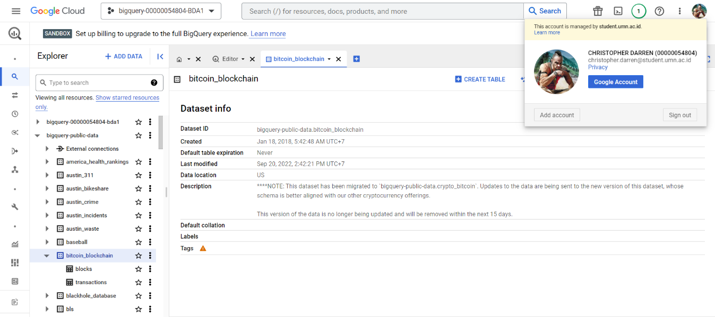
  6. c. The public dataset used and the appearance of its contents are in accordance with the Figure 1.1

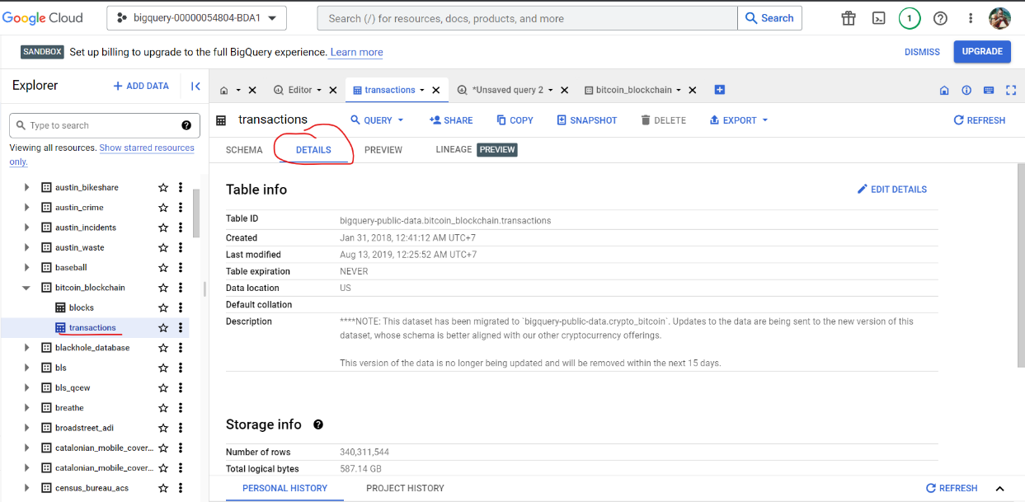

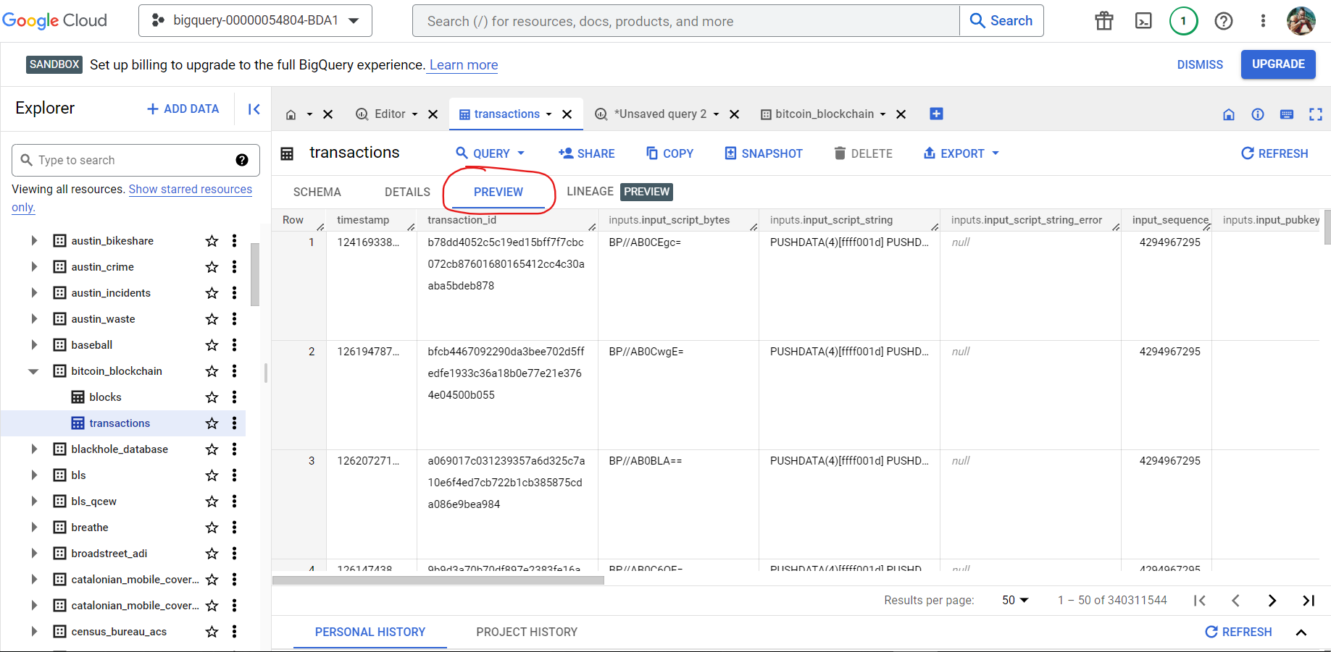

**Figure 1.1**

**2. Query Execution for 595.9 MB data-sets**

1. Using a public dataset from the World Bank, then perform a query in the query editor's query column and the resulting output is in accordance with Figure 1.2

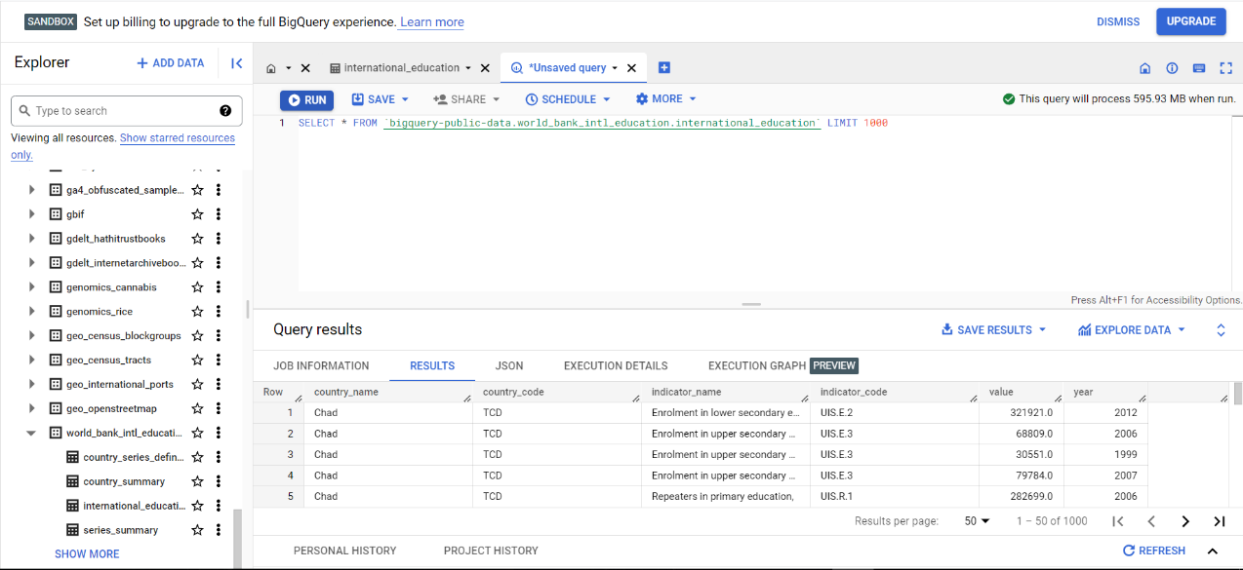

**Figure 1.2**

b. Congratulations! by executing the query, you have played with big data in amounts of 595.9 MB processed by 0.6 sec elapsed time.

**3. Creation Data-sets in GBQ**

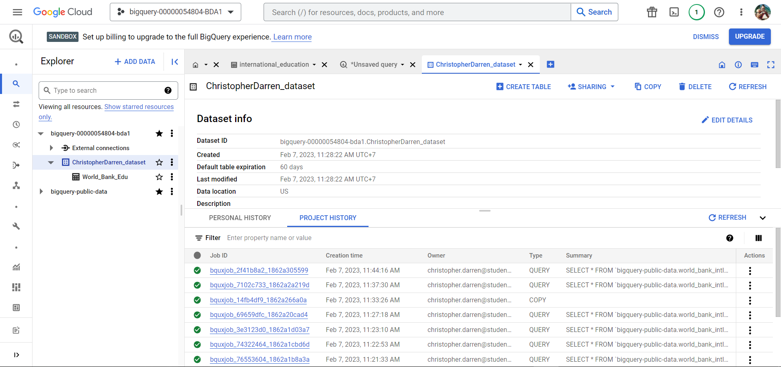

**Figure 1.3**

**4. Creation Data-sets in GBQ (final result)**

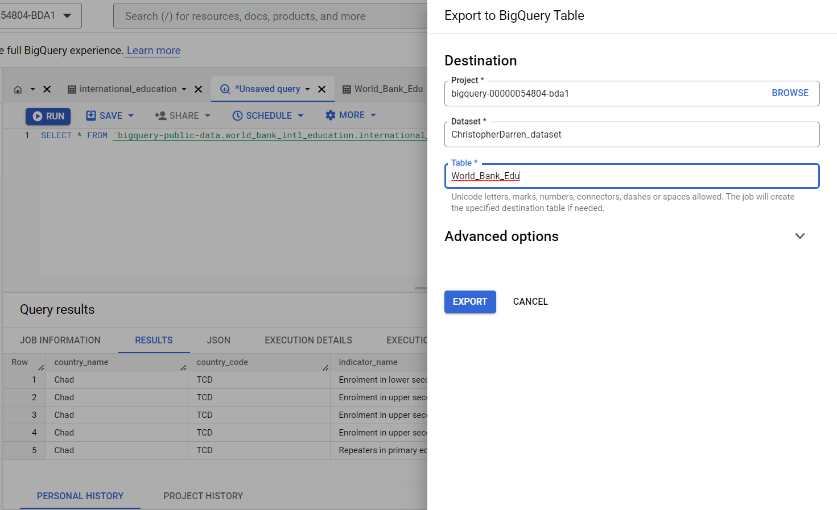

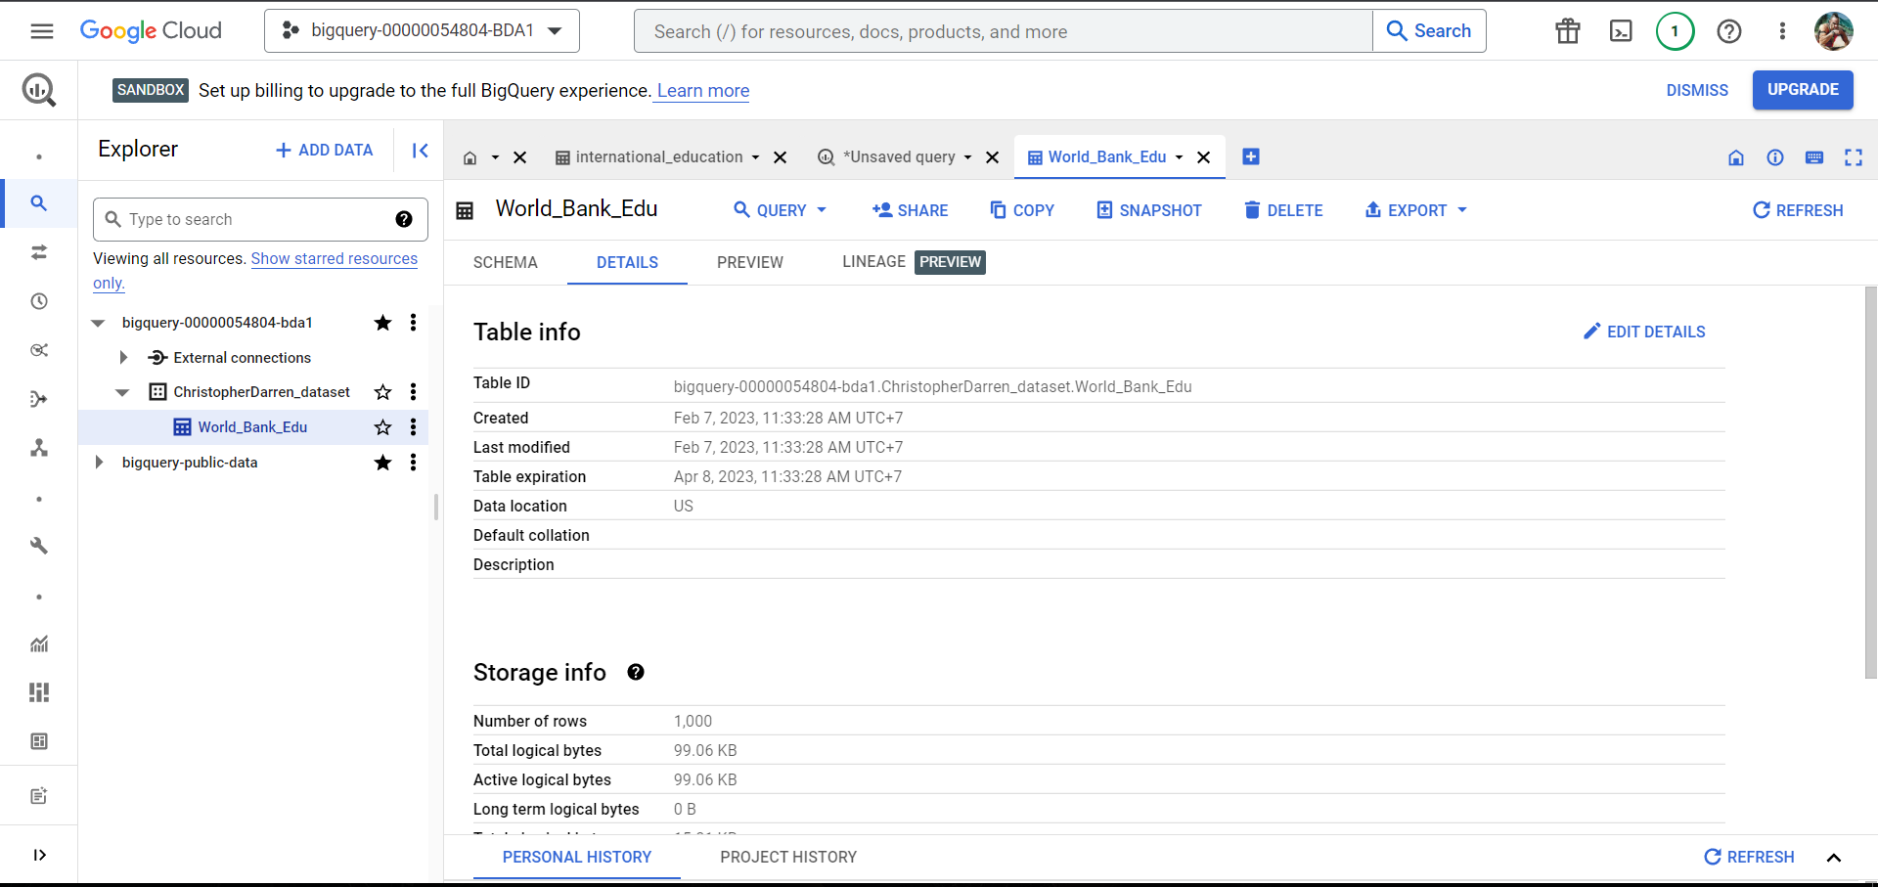

**Figure 1.4**

**Link Semua**

**Query 1 buat ubah limit jadi 1000 yang world bank:** <https://console.cloud.google.com/bigquery?sq=1036585851045:a197d855b08e44279c6293d075e5bb46>